Sao Tome and Principe

## Respect for rule of law (ROL) data

The data set shows the data on the respect of the rule of law for the country.

## # A tibble: 19 x 5  
## country iso3c date ruleOfLaw ruleOfLawCategory4   
## <chr> <chr> <dbl> <dbl> <chr>   
## 1 Sao Tome and Principe STP 1996 0.269 ROL moderately respected   
## 2 Sao Tome and Principe STP 1998 -0.203 ROL moderately disrespected  
## 3 Sao Tome and Principe STP 2000 -0.0218 ROL moderately disrespected  
## 4 Sao Tome and Principe STP 2002 -0.424 ROL moderately disrespected  
## 5 Sao Tome and Principe STP 2003 -0.400 ROL moderately disrespected  
## 6 Sao Tome and Principe STP 2004 -0.319 ROL moderately disrespected  
## 7 Sao Tome and Principe STP 2005 -0.532 ROL moderately disrespected  
## 8 Sao Tome and Principe STP 2006 -0.492 ROL moderately disrespected  
## 9 Sao Tome and Principe STP 2007 -0.434 ROL moderately disrespected  
## 10 Sao Tome and Principe STP 2008 -0.485 ROL moderately disrespected  
## 11 Sao Tome and Principe STP 2009 -0.677 ROL moderately disrespected  
## 12 Sao Tome and Principe STP 2010 -0.663 ROL moderately disrespected  
## 13 Sao Tome and Principe STP 2011 -0.661 ROL moderately disrespected  
## 14 Sao Tome and Principe STP 2012 -0.748 ROL moderately disrespected  
## 15 Sao Tome and Principe STP 2013 -0.768 ROL moderately disrespected  
## 16 Sao Tome and Principe STP 2014 -0.793 ROL moderately disrespected  
## 17 Sao Tome and Principe STP 2015 -0.756 ROL moderately disrespected  
## 18 Sao Tome and Principe STP 2016 -0.663 ROL moderately disrespected  
## 19 Sao Tome and Principe STP 2017 -0.682 ROL moderately disrespected

## Respect for rule of law (ROL) trend

The plot shows the trend of the respect for the rule of law for the country.

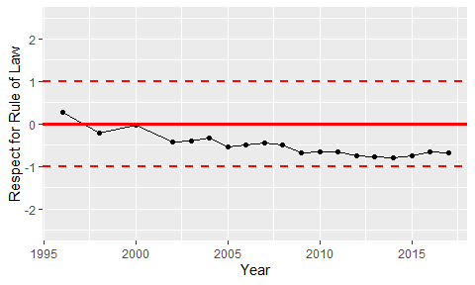

Trend of the Respect for the Rule of Law